CSC111 Final Exam Cheatsheet
Decimal, Binary and Hex
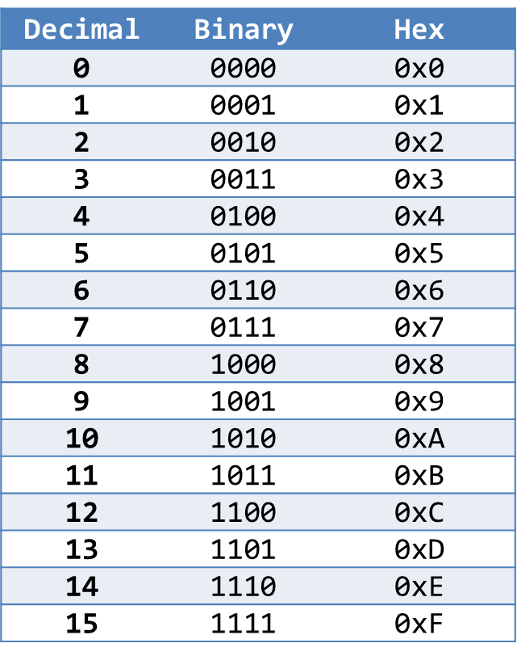
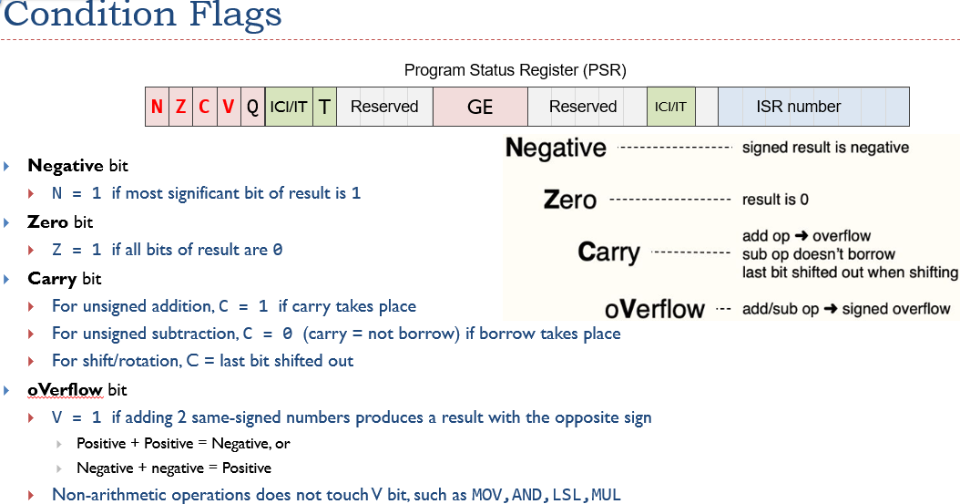
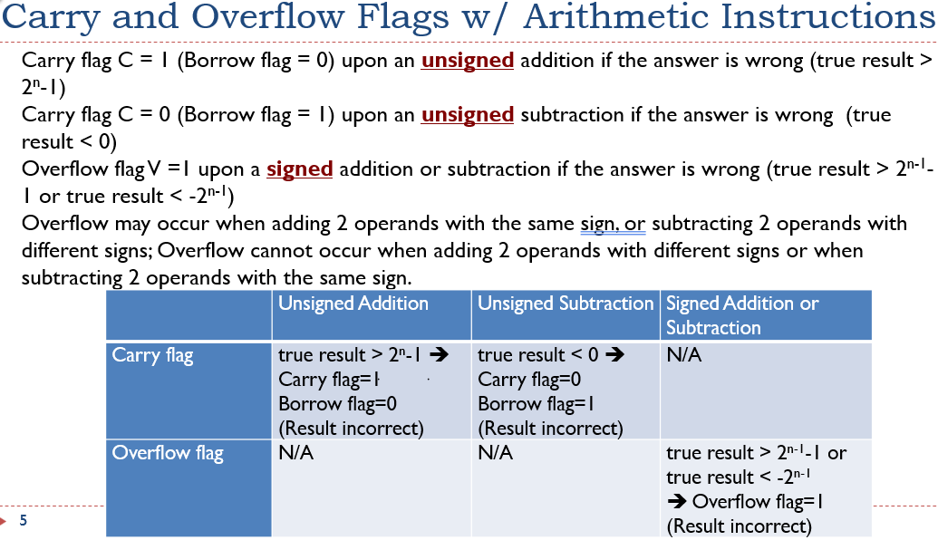
Condition Codes
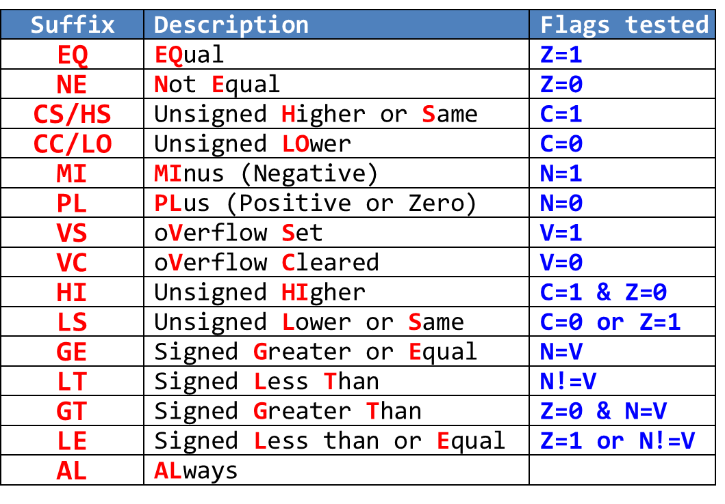
- Condition Codes:
  - EQ/NE: Z=1 / Z=0 (Equal/Not Equal)
  - LT/GE: N≠V / N=V (Signed Less Than/Greater Equal)
  - GT/LE: Z=0 & N=V / Z=1 or N≠V (Signed Greater/Less Equal)
  - LO/HS: C=0 / C=1 (Unsigned Lower/Higher Same)
  - HI/LS: C=1 & Z=0 / C=0 or Z=1 (Unsigned Higher/Lower Same)
- Flag Setting Instructions:
  - CMP: R1 - R2 (result discarded)
  - TST: R1 & R2 (result discarded)
  - TEQ: R1 ⊕ R2 (result discarded)
  - CMN: R1 + R2 (result discarded)

Branch Instructions
